The Project Implementation Plan
  - Project Overview & Project Characteristics
This document contains relevant project management tables related to the IP course “SDI Implementations”. The specific Project focuses on the implementation of a disaster prevention map in the cross-border regions of Salzburg and the “Nationalpark Berchtesgaden”.

Document version
Document changes are recorded in Table 1.
Table 1: Document version
Nr. | Date | Version | Altered chapters | Type of altering | Author
1 | 08.04.2026 | 1.1 | 1, 2 | Creation | Louis Schmalisch
2 | 10.04.2026 | 1.2 | 3, 4, 5 | Creation | Louis Schmalisch
3 | 11.04.2026 | 1.3 | 6 | Creation | Louis Schmalisch
4 | 22.04.2026 | 1.4 | 6 | Editing | Louis Schmalisch
5

Project information
A project overview shown in Table 2.
Table 2: Overall project information
Project
Acronym | SDI_IWS
Title | Berchtesgaden integrated warning System
Period | Start: | 2026-03-03 | End: | 2026-06-23
Principal investigator | Dr. Manfred Mittlböck  Dipl.-Ing., Mag. Eva-Maria Steinbacher  Assoc. Prof. Dr. Hermann Klug
Contractor | Course: “SDI Implementation”

Project Content and Project Goals
A short description of the project is provided in Table 3.
Table 3: Project Content and Project Goals
Content & Goals
Project description (~100-150 words)
The alpine region is prone to natural disaster, even more so due to the climate change. For safety and prevention, this project focuses on the development of a transboundary spatial data infrastructure (SDI), that can act as an early warning system for the Berchtesgaden national park and the surrounding Salzburg region. To achieve this, the harmonization of datasets, regulations and semantic definitions is the basis. Additionally, an integration of areas with special interest (in the context of biodiversity) and hazard zones will be integrated. By combining static historic data, like land-use or natural disaster events with real-time data especially meteorological data (from Germany and Austria), the system creates a comprehensive overview of the regions vulnerabilities. The SDI combines up-to-date topological data – analysing critical terrain like slope, aspect and hill shade to identify possible danger zones – with dynamic climate data streams. Utilizing OGC standard based web publication (OGC API or WMS, WTMS, etc.) this project bridges the gap between static data and live weather triggers, providing a highly interoperable natural disaster management forecast.
Project purpose, benefits and target group description (~100 words)
National legislation presents a problem in transboundary regions, like Berchtesgaden/Salzburg. Each nation has their own coordinate reference system (CRS), data, and semantic definitions for words/workflows. With this project, these challenges get tackled, by harmonizing the different data and merge them into one scenario, finding hazardous areas according to both semantic definitions and making the results accessible via a standard based web service. By providing the infrastructure and the combination of the different data used by the nations, the prediction of naturals disasters should be more accurate. With blue-light organizations in mind, this project aims to provide an easy and accessible way of anticipating possible natural disasters and therefore give them more time to prepare and communicate the according measures to the inhabitants.
Project objectives (please also include a listing of the sub-goals) (~100 words)
The main goal is to build an SDI structure across key geoinformatics domains. The technical result should be an up-to date map layers available for end-users via OGC standardised WMS/WFS and or OGC API.
- Harmonization and ingestion of historic data (prior natural disasters, land use) across boarders
- SDI needs to integrate relevant static data (mobility, land-use, buildings, biodiversity)
- High resolution topographic basemap (slope & aspect for deriving possible danger zones e.g. hill slides)
- Including real-time meteorological data via APIs (weather forecast including rain/snowfall for possible disasters) into spatial database
Non-Goals
- Real-time machine learning prediction algorithm with on-the-fly calculations of new hazard zones
- Creation of new predictive mathematical models
- No attempt of rewriting/altering of legal and official binding hazard zones

Frame of the project
Please provide a description of the existing situation. Therefore, please describe the actual state and the identified challenges. As a second part, please also provide the most important information regarding the proposed project period and the most important dates (Kick-off, interim/mid-term report/presentation, final report, paper submission etc.).
Table 4: Frame of the project – Part 1
Context
Up-to-date status (~50-100 words)
Currently the project is in data acquisition stage. For the real-time meteorological data, the DWD (Germany) and GeoSphere (Austria) provides us the needed APIs/WMS. For topographic data using open-source governmental data. For navigation/streets/hiking open-source data from OSM needs to be fully checked out. Biodiversity data can be found on GBIF. In addition, we are currently investigating the differences between the two national handling of their geospatial data and the needed steeps for harmonization.
Project setting (~50 words)
The project is conducted as part of the IP-course “SDI Implementation” as part of the curriculum of the master’s program “Applied Geoinformatics”. While the project work is conducted in the mentioned course, the management of this project is part of the course “GI/EO Project Management”.
Table 5: Frame of the project – Part 2
Time frame of the project
Start: |  | 03.03.2026 |  | End: | 30.06.2026
Important Dates
1 | 18.03.2026 |  | Submission of Abstract
2 | 12.04.2026 |  | Submission of PIP
3 | 05.05.2026 |  | Mid-term presentation of project
4 | 30.05.2026 |  | First Prototype of full SDI
5 | 23.06.2026 |  | Final Presentation

Resources & Budget
Please provide information on the project lead and the project team. Please include information on name, role and qualification. Additionally provide information about the planned resources regarding personal costs and other costs.
Table 6: Resources and Budget – Part 1
Project Team
Project Lead
Louis Schmalisch (second semester M.Sc. Applied Geoinformatics)
Project Team
Mary Muthee (second semester Copernicus Mundus), Assad Ullah (fourth semester M.Sc. Applied Geoinformatics)
Table 7: Resources and Budget – Part 2
Resources
Personal costs
This project is part of our master’s degree and therefore not paid.
Project costs
The data of the project is expected to be free of charge. The infrastructure and the licences are provided by the University of Salzburg.
Other Costs
There are no further cost expected.

Project structure, description and risk matrix
Please provide a description about your work plan (work breakdown structure) your work packages in tabular and graphical form.

Work packages overview
Table 8: Work packages overview
WP | Name of the Work Package | Time Frame [to – from]
1 | Project Management and requirements overview | 03.03.2026 – 21.04.2026
2 | Data Acquisition | 21.04.2026 – 31.04.2026
3 | Data Processing | 01.05.2026 – 15.05.2026
4 | SDI development | 16.05.2026 – 14.06.2026
5 | Improvements and Feedback incorporating | 15.06.2026 – 22.06.2026
6 | Final Presentation | 23.06.2026
7 | Submission of Documentation and SDI | 23.06.2026

Work Breakdown Structure (WBS)
Create a work breakdown structure for your work packages including the important tasks.

Figure 1 Work breakdown Structure

Detailed work plan
Please document the goals, content and expected results for each work package. Provide information on the planned approach and methods you want to apply as well as the expected results (including the planned milestones and deliverables). As a first work package please use ‘project management ‘.
Table 9: Detailed Work Plan – WP1
WP 1 | Project management | Duration | 03.03.2026 – 21.04.2026
Project Lead | Project team
Louis Schmalisch | Mary Muthee, Assad Ullah
Objectives
Define and plan the project. Including task, goals, purposes, requirements and time management.
Content & Tasks
- Find a Topic and draft first Abstract
- Define objectives, the SDI should fulfil
- Define Target Group/Personas
- GitLab setup for digital and collaborative Project Management and documentation
Expected results
Project Implementation Plan, work plan with time estimates and GitLab.
Milestones & Deliverables
M1 Abstract (18.03.2026)
M2 Extended Abstract (04.04.2026)
M3 PIP (12.04.2026)
M4 GitLab
D1 Abstract (18.03.2026)
D2 Extended Abstract (04.04.2026)
D3 PIP (12.04.2026)
D4 GitLab with time plan and work packages

Table 10: Detailed Work Plan – WP2
WP 2 | Data Acquisition | Duration | 21.04.2026 – 31.04.2026
Project Lead | Project team
Louis Schmalisch | Mary Muthee, Assad Ullah
Objectives
Obtain relevant data
Content & Tasks
- Gather existing data
- Find historic data
- Grab APIs and WMS
- Review literature to find status-quo
Expected results
List of Datasets and resources on where to get data.
Milestones & Deliverables
M1 List of all Datasets (31.04.2026)
D1 Dataset-List

Table 11: Detailed Work Plan – WPn
WP 3 | Data Processing | Duration | 01.05.2026 – 15.05.2026
Project Lead | Project team
Louis Schmalisch | Mary Muthee, Assad Ullah
Objectives
Process the data to a usable level, mainly harmonization.
Content & Tasks
- Harmonize data’s crs
- Standardise data to OGC WMS/OGC APIs
- Ensure comparability of data
Expected results
Complete harmonized and standardised (OGC) dataset.
Milestones & Deliverables
M1 Finished WP 2 & 3 (15.05.2026)
D1 Dataset

WP 4 | SDI Development | Duration | 16.05.2026 – 14.06.2026
Project Lead | Project team
Louis Schmalisch | Mary Muthee, Assad Ulla
Objectives
Setup whole SDI architecture.
Content & Tasks
- Integrate data in PostGIS database
- Provide project as WMS/API or Geoserver
- Set up user interface
Expected results
Complete SDI platform
Milestones & Deliverables
M1 First prototype SDI platform (14.06.2026)
D1 Database
D2 user interface
D3 Publication (WMS/API or Geoserver)

WP 5 | Feedback | Duration | 15.06.2026 – 22.06.2026
Project Lead | Project team
Louis Schmalisch | Mary Muthee, Assad Ullah
Objectives
Getting user feedback for improvement
Content & Tasks
- Get feedback from users
- Use feedback for SDI improvement
Expected results
Updated SDI platform with improvements
Milestones & Deliverables
M1 Final SDI platform (22.06.2026)
D1 Improved SDI

WP 6 | Final Presentation and Submission | Duration | 23.06.2026
Project Lead | Project team
Louis Schmalisch | Mary Muthee, Assad Ullah
Objectives
Final presentation of the Project and the submission of the full documentation.
Content & Tasks
- Final Presentation
- GitLab with documentation of steps, workflow and methods
- Written Report
Expected results
- Final Presentation
- GitLab repository
Milestones & Deliverables
M1 Final Presentation (23.06.2026)
M2 GitLab repository (23.06.2026)
D1 Presentation
D2 GitLab repository
D3 written report

Milestone plan
Please provide a summary of the planned milestones and provide an according overview graphic.
Table 12: Milestone plan
MS | Name | Date Completion
M1 | Submission of Abstract | 18.03.2026
M2 | Submission of Extended Abstract | 04.04.2026
M3 | Submission of PIP | 12.04.2026
M4 | List of all Datasets | 31.04.2026
M5 | Mid-term presentation of Project | 05.05.2026
M6 | Finished WP 2 & 3 | 15.05.2026
M7 | First Prototype | 14.06.2026
M8 | Final SDI Platform | 22.06.2026
M9 | Project Presentation | 23.06.2026
M10 | GitLab repository Submission | 23.06.2026
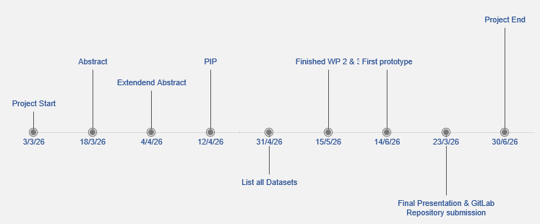
Figure 2 Milestones (from Excel template)

Gantt Chart
Please provide an image of your Gantt chart as overview graphics. Please attach the Gantt chart and its monthly updates in addition to this document.
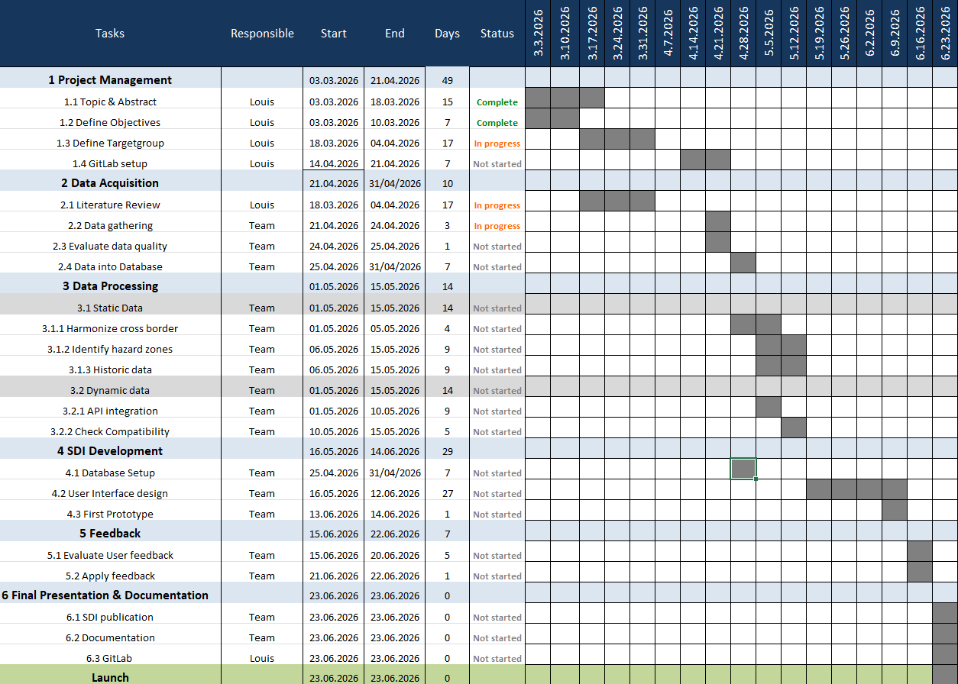
Table 13: Milestone plan

Risk Matrix
In this table, please provide the important risk information. Please categorize the risks accordingly. ([L]ow, [M]edium, [H]igh], [C]leared) as well as your mitigation strategy. Please update this list accordingly during your project execution time frame.
Table 14: Risk matrix
No | Risk | Potential adverse impact | Risk level* | Risk management strategy | Responsibility
1 | Missing/incomplete data | Limited analysis | L | Use of alternative datasets | Louis
2 | Missing spots on/near border | No true calculation of hazard zones | M/H | Estimate missing spots | Team
3 | Time | Incomplete project or missing functionality | M | Skip unnecessary functionalities | Team
4 | No feedback | no adaption to users possible | L | Ask Enough users | Team
5 | Technical difficulties | Never implemented an SDI | M | Help from Instructors; AI | Team

Additional comments
Add additional comments if necessary.
Table 15: Additional comments
Comments

Approval
Please provide further information if necessary.
Table 16: Approval
Freigabe
Date: | dd.mm.yyyy | Date: | dd.mm.yyyy
Signature principal investigator |  | Signature project lead/contractor

